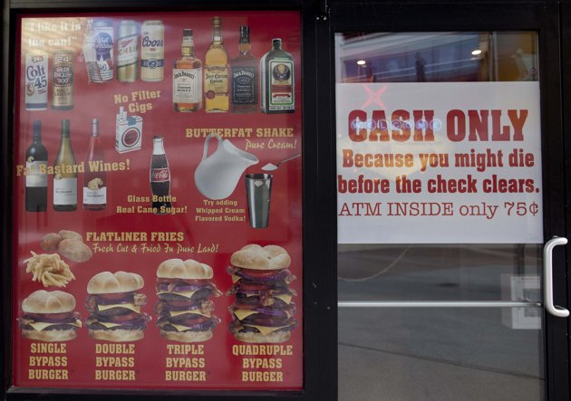

Is this the most dangerous restaurant in the world? (Yahoo News )
Heart Attack Grill 'mascot' dies - of a heart attack! He is their second mascot to die in the past two years

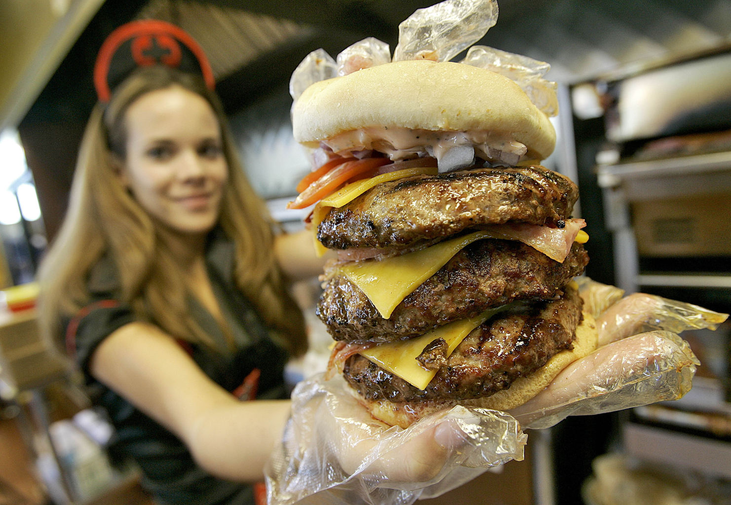
A man who dined everyday at the 'Heart Attack Grill' has died - of a heart attack.
John Alleman, 52, was such a regular visitor he was branded the unofficial mascot of the restaurant, which uses the tagline: "Taste worth dying for". He is the second mascot to die in the past two years.
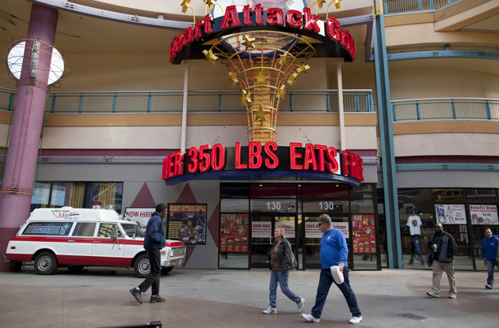
Mr Alleman collapsed in front of the diner in Las Vegas while waiting for a bus and was taken off life support on Monday.Owner Jon Basso said that Mr Alleman went to the restaurant daily and encouraged passing tourists to try its dishes. He said: "He never missed a day, even on Christmas. People just loved him. He connected with people in a real way."The infamous diner offers huge hamburgers, extra-fat milkshakes and chips cooked in lard.Waitresses are dressed in nurse costumes while the owner's picture graces the merchandise and menu, branded with the name "Patient Joe".
Diners are given surgical gowns as they chose from the menu which includes dishes such as the Coronary Hot Dog.In 2011, 41-stone (260kg)Blair River, also an unofficial promoter, died aged just 29. Pneumonia was said to be the cause of his death at the time.A year later a man in his 40s was hospitalised after he began sweating and shaking while eating a 6,000 calorie Triple Bypass burger at the diner.Mr Basso said Mr Alleman weighed an estimated 13 stones(82kg) and his death showed heart attacks can happen to anyone.

350lbs=158kg
Conversation questions:

1.What did you think after reading the text? What do the words in bold print mean?

2. Do you think such a restaurant would be successful in Paris?

3. Do you think such places should be forbidden?

4. Do you know what “pig out “ means?

5. Why do you think Jon Brasso opened such a restaurant?

6. What foodstuffs/food can’t you resist?

7. Do you think the portions served in your country’s restaurants are too big?

8. How big should portions at mealtimes be?

9. Do you think it is dangerous to force children to “eat everything on yout plate”?

10.Why do you think obesity is becoming a world-wide problem? Or is it? Are there countries in

which it isn’t a problem?

